Week-1 Find-S

import io

import csv

import pandas as pd

num_attributes=6

a=[]

print("The given Dataset is")

with open("C:\\Users\\vshiv\\OneDrive\\Desktop\\MLDS CSV FILES\\Climate1.csv",'r') as csvfile:

reader=csv.reader(csvfile)

for row in reader:

a.append(row)

print(row)

print("The initial hypothesis is")

hypothesis=['0']*num_attributes

print(hypothesis)

for j in range(0,num_attributes):

hypothesis[j]=a[1][j]

print(hypothesis)

#Find the Maximum specific Hypothesis

print("Find S: Finding maximal Specific Hypothesis")

for i in range(1,len(a)):

if a[i][num_attributes]=='Yes' or a[i][num_attributes]== 'yes':

for j in range(0,num_attributes):

if a[i][j]!=hypothesis[j]:

hypothesis[j]='?'

else :

hypothesis[j]=a[i][j]

print("For Training instance No: {0} the hypothesis is ". format(i), hypothesis)

print("The hypothesis is:")

print(hypothesis)

O/P:

The given Dataset is

['sky', 'Airtemp', 'Humidity', 'Wind', 'Water ', 'Forecast ', 'EnjoySport']

['Sunny', 'Warm ', 'Normal ', 'Strong ', 'Warm', 'Same', 'Yes']

['Sunny', 'Warm ', 'High', 'Strong ', 'Warm', 'Same', 'Yes']

['Rainy ', 'Cold', 'High', 'Strong ', 'Warm', 'change', 'No']

['Sunny', 'Warm ', 'High', 'Strong ', 'Cool', 'change', 'Yes']

The initial hypothesis is

['0', '0', '0', '0', '0', '0']

['Sunny', 'Warm ', 'Normal ', 'Strong ', 'Warm', 'Same']

Find S: Finding maximal Specific Hypothesis

For Training instance No: 1 the hypothesis is ['Sunny', 'Warm ', 'Normal ', 'Strong ', 'Warm', 'Same']

For Training instance No: 2 the hypothesis is ['Sunny', 'Warm ', '?', 'Strong ', 'Warm', 'Same']

For Training instance No: 3 the hypothesis is ['Sunny', 'Warm ', '?', 'Strong ', 'Warm', 'Same']

For Training instance No: 4 the hypothesis is ['Sunny', 'Warm ', '?', 'Strong ', '?', '?']

The hypothesis is:

['Sunny', 'Warm ', '?', 'Strong ', '?', '?']

Week-5:

from sklearn.model_selection import train_test_split

from sklearn.neighbors import KNeighborsClassifier

from sklearn import datasets

import pandas as pd

import numpy as np

iris=datasets.load_iris()

print("Iris Data set loaded...")

x_train, x_test, y_train, y_test= train_test_split(iris.data,iris.target,test_size=0.2)

print("Dataset is split into Training and Testing...")

print("Size of training data and it's label",x_train.shape,y_train.shape)

print("Size of Test data and it's label",x_test.shape,y_test.shape)

for i in range(len(iris.target_names)):

print("Label",i,"-",str(iris.target_names[i]))

classifier=KNeighborsClassifier(n_neighbors=1)

classifier.fit(x_train,y_train)

y_pred=classifier.predict(x_test)

print("Result of Classification using K-NN with K=1")

for r in range(0,len(x_test)):

print("Sample:",str(x_test[r]),"Actual-label:",str(y_test[r]),"PredictedLabel:",str(y_pred[r]))

print("Classification Accuracy:",classifier.score(x_test,y_test))

from sklearn.metrics import classification_report, confusion_matrix

print("Confusion Matrix")

print(confusion_matrix(y_test,y_pred))

print("Accuracy Matrix")

print(classification_report(y_test,y_pred))

O/P:

Iris Data set loaded...

Dataset is split into Training and Testing...

Size of training data and it's label (120, 4) (120,)

Size of Test data and it's label (30, 4) (30,)

Label 0 - setosa

Label 1 - versicolor

Label 2 - virginica

Result of Classification using K-NN with K=1

Sample: [6. 2.2 4. 1. ] Actual-label: 1 PredictedLabel: 1

Sample: [6.5 3. 5.8 2.2] Actual-label: 2 PredictedLabel: 2

Sample: [5.2 4.1 1.5 0.1] Actual-label: 0 PredictedLabel: 0

Sample: [5. 3.5 1.3 0.3] Actual-label: 0 PredictedLabel: 0

Sample: [4.9 2.4 3.3 1. ] Actual-label: 1 PredictedLabel: 1

Sample: [7.7 3.8 6.7 2.2] Actual-label: 2 PredictedLabel: 2

Sample: [6.1 3. 4.9 1.8] Actual-label: 2 PredictedLabel: 2

Sample: [6.4 3.1 5.5 1.8] Actual-label: 2 PredictedLabel: 2

Sample: [6.4 3.2 5.3 2.3] Actual-label: 2 PredictedLabel: 2

Sample: [6.2 2.9 4.3 1.3] Actual-label: 1 PredictedLabel: 1

Sample: [4.9 3. 1.4 0.2] Actual-label: 0 PredictedLabel: 0

Sample: [6.5 2.8 4.6 1.5] Actual-label: 1 PredictedLabel: 1

Sample: [4.4 3.2 1.3 0.2] Actual-label: 0 PredictedLabel: 0

Sample: [4.8 3.4 1.9 0.2] Actual-label: 0 PredictedLabel: 0

Sample: [6.3 2.9 5.6 1.8] Actual-label: 2 PredictedLabel: 2

Sample: [5.7 2.8 4.1 1.3] Actual-label: 1 PredictedLabel: 1

Sample: [5.8 2.7 3.9 1.2] Actual-label: 1 PredictedLabel: 1

Sample: [5.7 3. 4.2 1.2] Actual-label: 1 PredictedLabel: 1

Sample: [5.9 3. 4.2 1.5] Actual-label: 1 PredictedLabel: 1

Sample: [6.3 2.3 4.4 1.3] Actual-label: 1 PredictedLabel: 1

Sample: [6. 2.9 4.5 1.5] Actual-label: 1 PredictedLabel: 1

Sample: [4.4 2.9 1.4 0.2] Actual-label: 0 PredictedLabel: 0

Sample: [6.1 2.6 5.6 1.4] Actual-label: 2 PredictedLabel: 2

Sample: [7.6 3. 6.6 2.1] Actual-label: 2 PredictedLabel: 2

Sample: [6. 2.7 5.1 1.6] Actual-label: 1 PredictedLabel: 2

Sample: [5.1 3.8 1.9 0.4] Actual-label: 0 PredictedLabel: 0

Sample: [5.5 2.3 4. 1.3] Actual-label: 1 PredictedLabel: 1

Sample: [5.8 2.6 4. 1.2] Actual-label: 1 PredictedLabel: 1

Sample: [5. 3.2 1.2 0.2] Actual-label: 0 PredictedLabel: 0

Sample: [6.4 2.7 5.3 1.9] Actual-label: 2 PredictedLabel: 2

Classification Accuracy: 0.9666666666666667

Confusion Matrix

[[ 8 0 0]

[ 0 12 1]

[ 0 0 9]]

Accuracy Matrix

precision recall f1-score support

0 1.00 1.00 1.00 8

1 1.00 0.92 0.96 13

2 0.90 1.00 0.95 9

accuracy 0.97 30

macro avg 0.97 0.97 0.97 30

weighted avg 0.97 0.97 0.97 30

Week-3:

import matplotlib.pyplot as plt

import pandas as pd

import numpy as np

def kernel(point, xmat, k):

m,n = np.shape(xmat)

weights = np.mat(np.eye((m)))

for j in range(m):

diff = point - X[j]

print("Point",point)

print("Diff",diff)

weights[j,j] = np.exp(diff*diff.T/(-2.0*k**2))

print("Weights",weights)

return weights

def localWeight(point, xmat, ymat, k):

wei = kernel(point,xmat,k)

W = (X.T*(wei*X)).I*(X.T*(wei*ymat.T))

print("W",W)

return W

def localWeightRegression(xmat, ymat, k):

m,n = np.shape(xmat)

ypred = np.zeros(m)

for i in range(m):

ypred[i] = xmat[i]*localWeight(xmat[i],xmat,ymat,k)

return ypred

# load data points

data = pd.read_csv("E:\\3-2\\MLDS\\Datasets\\week3.csv")

bill = np.array(data.total_bill)

tip = np.array(data.tip)

#preparing and add 1 in bill

mbill = np.mat(bill)

print("MBILL",mbill)

mtip = np.mat(tip)

print("Mtip",mtip)

m= np.shape(mbill)[1]

one = np.mat(np.ones(m))

X = np.hstack((one.T,mbill.T))

print("X",X)

#set k here

ypred = localWeightRegression(X,mtip,2)

SortIndex = X[:,1].argsort(0)

xsort = X[SortIndex][:,0]

fig = plt.figure()

ax = fig.add_subplot(1,1,1)

ax.scatter(bill,tip, color='green')

ax.plot(xsort[:,1],ypred[SortIndex], color = 'red', linewidth=5)

plt.xlabel('Total bill')

plt.ylabel('Tip')

plt.show()

O/P:

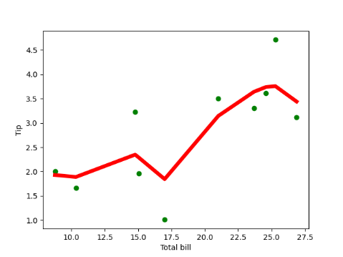

MBILL [[16.99 10.34 21.01 23.68 24.59 25.29 8.77 26.88 15.04 14.78]]

Mtip [[1.01 1.66 3.5 3.31 3.61 4.71 2. 3.12 1.96 3.23]]

X [[ 1. 16.99]

[ 1. 10.34]

[ 1. 21.01]

[ 1. 23.68]

[ 1. 24.59]

[ 1. 25.29]

[ 1. 8.77]

[ 1. 26.88]

[ 1. 15.04]

[ 1. 14.78]]

Point [[ 1. 16.99]]

Diff [[0. 0.]]

Week-4:

import matplotlib.pyplot as plt

from sklearn import datasets

from sklearn.cluster import KMeans

import sklearn.metrics as sm

import pandas as pd

import numpy as np

iris =datasets.load_iris()

X=pd.DataFrame(iris.data)

print(X.shape)

X.columns=['Sepal_Length','Sepal_Width', 'Petal_length', 'Petal_Width']

y=pd.DataFrame(iris.target)

y.columns=['target']

plt.figure(figsize=(14,7))

colormap=np.array(['red','lime','black'])

plt.subplot(1,2,1)

plt.scatter(X.Sepal_Length,X.Sepal_Width,c=colormap[y.target],s=40)

plt.title('Sepal')

plt.subplot(1,2,2)

plt.scatter(X.Petal_length,X.Petal_Width,c=colormap[y.target],s=40)

plt.title('Petal')

plt.show()

model=KMeans(n_clusters=3)

model.fit(X)

print(model.labels_)

plt.subplot(1,2,1)

plt.scatter(X.Petal_length,X.Petal_Width,c=colormap[y.target],s=40)

plt.title('Real Classification')

plt.subplot(1,2,2)

plt.scatter(X.Petal_length,X.Petal_Width,c=colormap[model.labels_],s=40)

plt.title( 'KMEANS Classfication')

plt.show()

print(sm.accuracy_score(y,model.labels_))

print(sm.confusion_matrix(y,model.labels_))

from sklearn.naive_bayes import GaussianNB

clf=GaussianNB()

clf.fit(X,y)

y_cluster_gmm=clf.predict(X)

print(y_cluster_gmm)

plt.subplot(1,2,1)

plt.scatter(X.Petal_length,X.Petal_Width,c=colormap[y.target],s=40)

plt.title('Real Classification')

plt.subplot(1,2,2)

plt.scatter(X.Petal_length,X.Petal_Width,c=colormap[y_cluster_gmm],s=40)

plt.title("Naive Bayesian Classification")

plt.show()

print(sm.accuracy_score(y,y_cluster_gmm))

print(sm.confusion_matrix(y,y_cluster_gmm))

#print(confusion_matrix)

O/P:

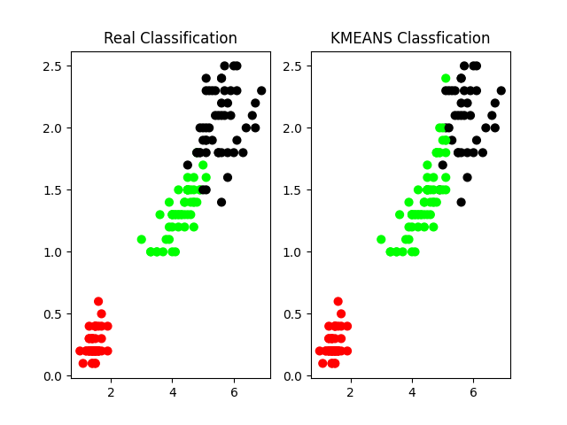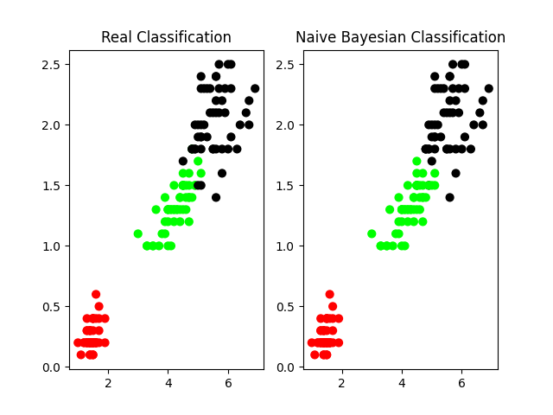

[0 0 0 0 0 0 0 0 0 0 0 0 0 0 0 0 0 0 0 0 0 0 0 0 0 0 0 0 0 0 0 0 0 0 0 0 0

0 0 0 0 0 0 0 0 0 0 0 0 0 1 1 2 1 1 1 1 1 1 1 1 1 1 1 1 1 1 1 1 1 2 1 1 1

1 1 1 2 1 1 1 1 1 1 1 1 1 1 1 1 1 1 1 1 1 1 1 1 1 1 2 2 2 2 2 2 1 2 2 2 2

2 2 2 2 2 2 2 2 1 2 2 2 2 2 2 2 2 2 2 2 2 2 1 2 2 2 2 2 2 2 2 2 2 2 2 2 2

2 2]

0.96

[[50 0 0]

[ 0 47 3]

Week-2

import pandas as pd

df=pd.read_csv("C:\\Users\\vshiv\\OneDrive\\Desktop\\MLDS CSV FILES\\lab2dataset.csv")

print(df)

def entropy(probs):

import math

return sum(-prob*math.log(prob,2) for prob in probs)

def entropy_of_list(a_list):

from collections import Counter

cnt = Counter (x for x in a_list)

num_instances =len(a_list)

probs=[x/num_instances for x in cnt.values()]

return entropy(probs)

total_entropy= entropy_of_list(df['PlayTime'])

print(total_entropy)

def information_gain(df,split_attribute_name, target_attribute_name, trace=0):

df_split =df.groupby(split_attribute_name)

for name,group in df_split:

nobs=len(df.index)*1.0

df_agg_ent=df_split.agg({target_attribute_name: [entropy_of_list,lambda x: len(x)/nobs] })[target_attribute_name]

avg_info=sum(df_agg_ent['entropy_of_list'] * df_agg_ent['<lambda_0>'])

old_entropy=entropy_of_list(df[target_attribute_name])

return old_entropy-avg_info

def id3DT(df, target_attribute_name, attribute_names, default_class=None):

from collections import Counter

cnt = Counter(x for x in df[target_attribute_name])

if len(cnt)==1:

return next(iter(cnt))

elif df.empty or (not attribute_names):

return default_class

else:

default_class =max(cnt.keys())

gainz=[information_gain(df,attr, target_attribute_name) for attr in attribute_names]

index_of_max=gainz.index(max(gainz))

best_attr=attribute_names[index_of_max]

tree={best_attr:{}}

remaining_attributes_names=[i for i in attribute_names if i != best_attr]

for attr_val, data_subset in df.groupby(best_attr):

subtree=id3DT(data_subset,target_attribute_name,remaining_attributes_names,default_class)

tree[best_attr][attr_val]=subtree

return tree

attribute_names=list(df.columns)

attribute_names.remove('PlayTime')

from pprint import pprint

tree= id3DT(df,'PlayTime',attribute_names)

print("The Resultant Decision Tree is ")

pprint(tree)

attribute=next(iter(tree))

print("Best Attribute: \n", attribute)

print("Tree Keys\n ", tree[attribute].keys())

def classify(instance, tree, default=None):

attribute=next(iter(tree))

print("Key:",tree.keys())

print("Attribute",attribute)

if instance[attribute] in tree[attribute].keys():

result=tree[attribute][instance[attribute]]

print("Instance Attribute:",instance[attribute], "TreeKeys:",tree[attribute].keys())

if isinstance(result,dict):

return classify(instance,result)

else:

return result

else:

return default

tree1={'Outlook':['Rainy','Sunny'],'Temperature':['Mild','Hot'],'Humidity':['Normal','High'],'Windy':['Weak','Strong']}

df2=pd.DataFrame(tree1)

df2['Predicted']=df2.apply(classify,axis=1, args=(tree,'No'))

print(df2)

Outlook Temperature Humidity Wind PlayTime

0 Sunny Hot High Weak No

1 Sunny Hot High Strong No

2 Overcast Hot High Weak Yes

3 Rain Mild High Weak Yes

4 Rain Cool Normal Weak Yes

5 Rain Cool Normal Strong No

6 Overcast Cool Normal Strong Yes

7 Sunny Mild High Weak No

8 Sunny Cool Normal Weak Yes

9 Rain Mild Normal Weak Yes

10 Overcast Mild High Strong Yes

11 Overcast Hot Normal Weak Yes

12 Rain Mild High Strong No

0.961236604722876

The Resultant Decision Tree is

{'Outlook': {'Overcast': 'Yes',

'Rain': {'Wind': {'Strong': 'No', 'Weak': 'Yes'}},

'Sunny': {'Temperature': {'Cool': 'Yes',

'Hot': 'No',

'Mild': 'No'}}}}

Best Attribute:

Outlook

Tree Keys

dict_keys(['Overcast', 'Rain', 'Sunny'])

Key: dict_keys(['Outlook'])

Attribute Outlook

Key: dict_keys(['Outlook'])

Attribute Outlook

Instance Attribute: Sunny TreeKeys: dict_keys(['Overcast', 'Rain', 'Sunny'])

Key: dict_keys(['Temperature'])

Attribute Temperature

Instance Attribute: Hot TreeKeys: dict_keys(['Cool', 'Hot', 'Mild'])

Outlook Temperature Humidity Windy Predicted

0 Rainy Mild Normal Weak No

1 Sunny Hot High Strong No